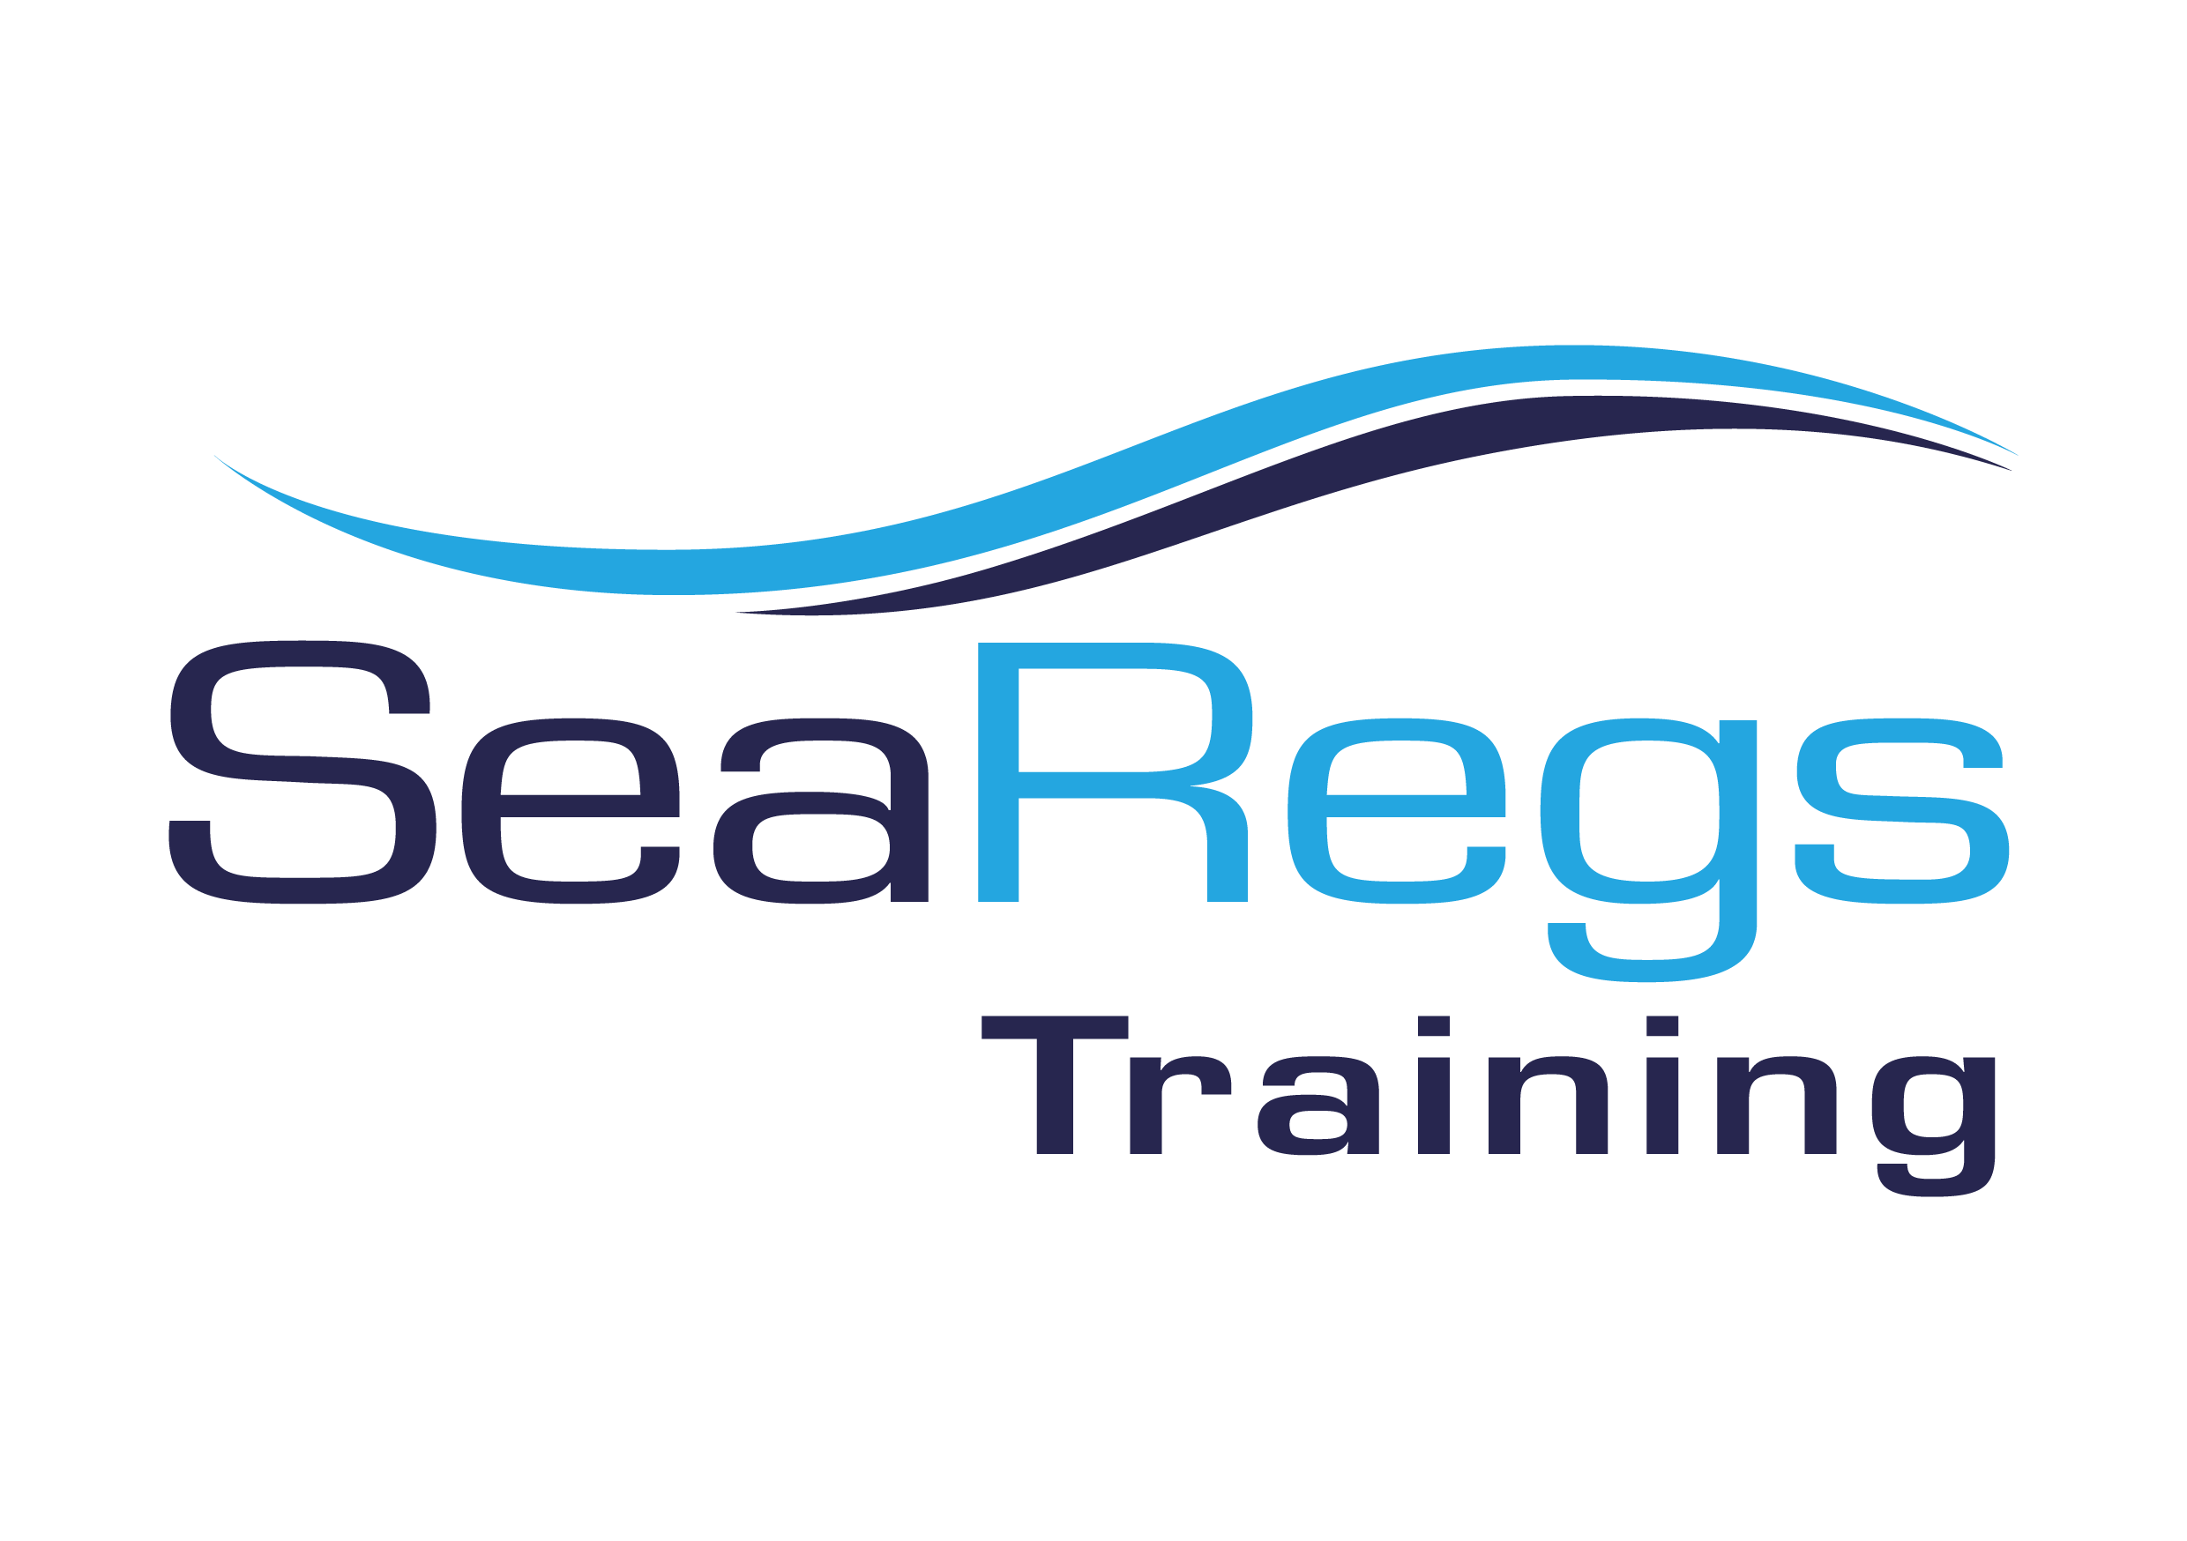
Interactive Courses Booking form

Personal details:
Name
Address
Mobile number |  | Home number
Email address |  | Date of birth

Course booking:
Course Name |  | Course fee | £
Relevant experience

Data Protection Act 1998:
The above will be used by us to process your booking for the course. We shall also include your name and address on our mailing list. If you do not want to receive details of future courses and events please tick here

I declare that:
I have read and accept the terms and conditions on the next page. I have completed the booking and medical details to the best of my knowledge and I am fit to participate in the course. I wish to book on the above named course(s) and I will arrange payment for the deposit/course fee.

Signed |  | Date
If under 18, this must be signed by a parent/guardian

Please return the completed form to:
admin@searegs.co.uk or
SeaRegs Training, Plymouth Marine Centre, Pomphlett Quay, Billacombe Road, Plymouth, PL9 7HP 01752 408270

Terms and conditions

General:
1. Before booking, please satisfy yourself that you have read adequate guidance as to the suitability of the course
you are booking. If in any doubt please contact us.
2. Bookings will be acknowledged by email with course access details.
3. Course enrolment does not mean that you automatically get a certificate. Students will be trained and debriefed to ensure everyone achieves their potential on the course but this may not mean that you receive a RYA certificate.
4. We welcome feedback, positive or not, as it is an opportunity for us to improve. Initially, please voice any concerns at the time to the instructor or Principal so that they can be quickly addressed.
5. RYA Dayskipper, Coastal Skipper/Yachtmaster Offshore and Yachtmaster Ocean interactive theory courses are run by Navathome. Terms and conditions for these courses can be viewed online - http://searegs.co.uk/online-course-booking/
Payments:
6. Payment is due in full at time of booking by using the online payment system. Payment by cheque or bank transfer can be made on request.
7. Postage of RYA Packs to UK addresses is included in the course cost, an additional charge will be payable to send the pack outside the UK.
Cancellations:
8. You can cancel your purchase up to 7 days from the day of delivery of the student pack. The pack must be complete, unopened and in an ‘as new’ condition. All materials must be returned. Access to the online course material is terminated immediately.
9. A refund will be made less a £30 administration fee. The cost of returning the student pack will be payable by the student.
10. You will not be able to claim a refund if the course material has been damaged or if you have no proof of purchase.
Liability and Insurance:
11. SeaRegs Training, its servants, agents and employees are not under any liability whatsoever in respect of loss or damage to personal effects or belongings howsoever caused, whilst attending a course. Consequently, irrespective of the legal basis on which any claim against us is made (except for claims for death or personal injury arising from our negligence) our total aggregate liability shall be limited to the sum of all payments received by us at the date of the incident or event giving rise to liability.
12. We shall not be liable to you in any circumstances for any consequential, special, exemplary or indirect losses costs or damages whether or not they might have been foreseeable, or for any damages costs or losses attributable to lost profits or opportunities.
13. You agree that if, as a matter of law, any of our directors, employees, consultants or agents would otherwise owe you a duty of care that duty is excluded from our Contract with you. You agree that you will not bring any claim against any of SeaRegs’ director, employee, consultant or agent for any matter arising in any way out of us or the consultant providing the services to you.
14. Accordingly any claim you wish to make can only be made against SeaRegs Training and not against any director, officer, employee, servant, agent or consultant.

